Fig S1. Molt limits in the 15 study species.
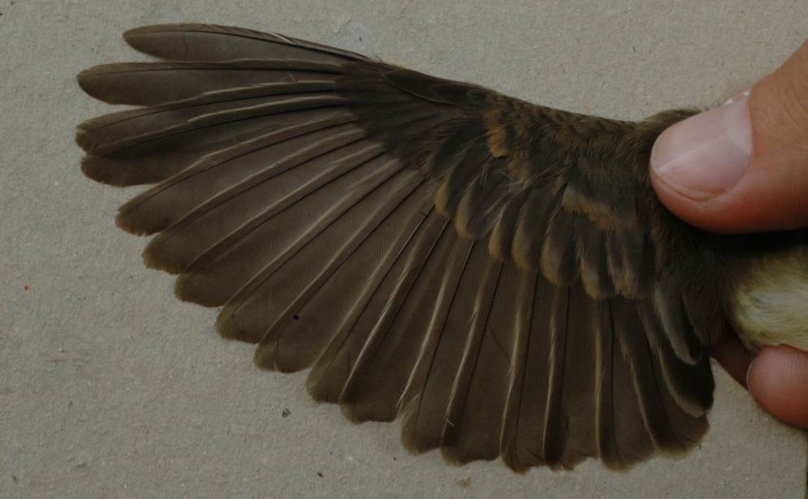
Northern Beardless-Tyrannulet in formative plumage.
24 Feb 2005.

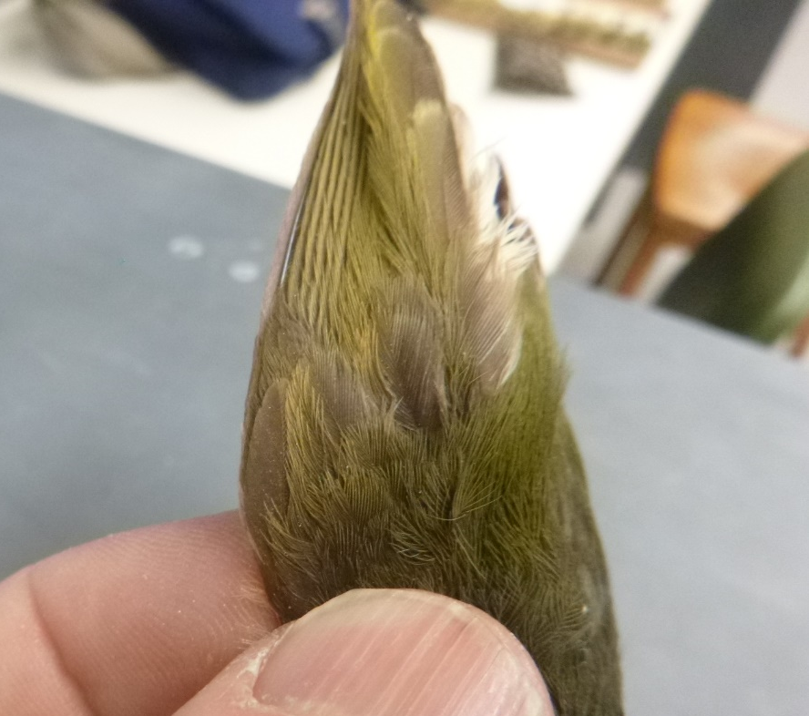
Ochre-bellied Flycatcher (MVZ 133735). Retained outer GC are paler and clearly abraded.
13 April 1955.
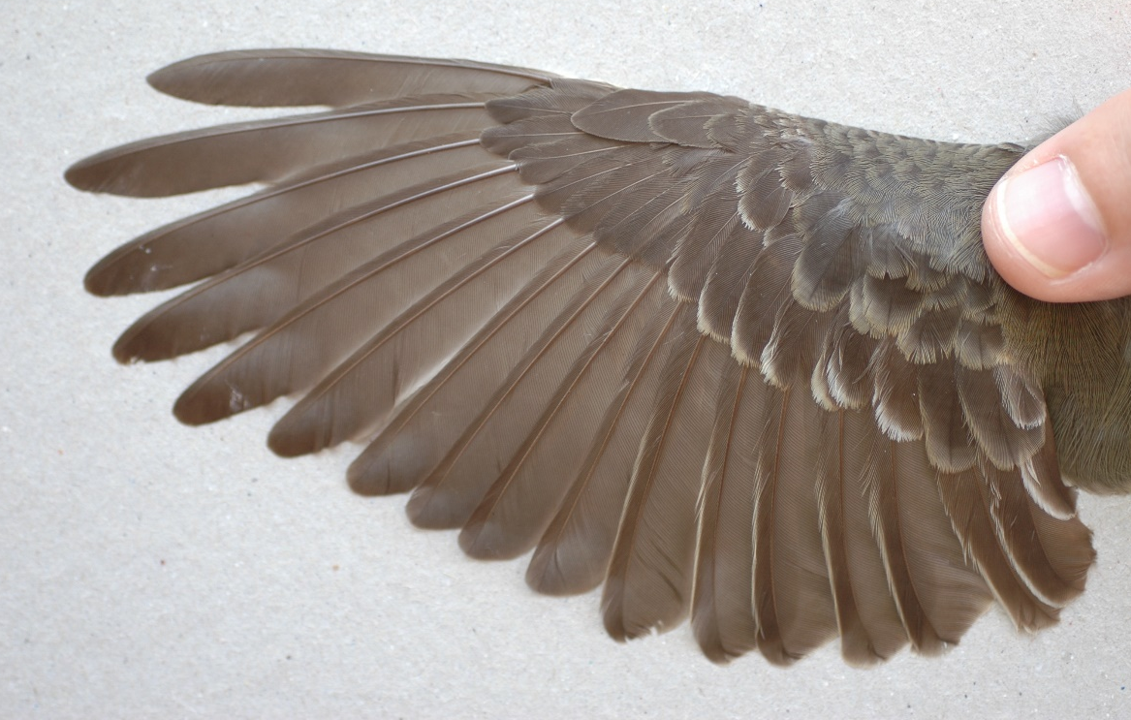
Greater Pewee. Formative wing coverts are larger and lack whitish margins.
29 November 2004.
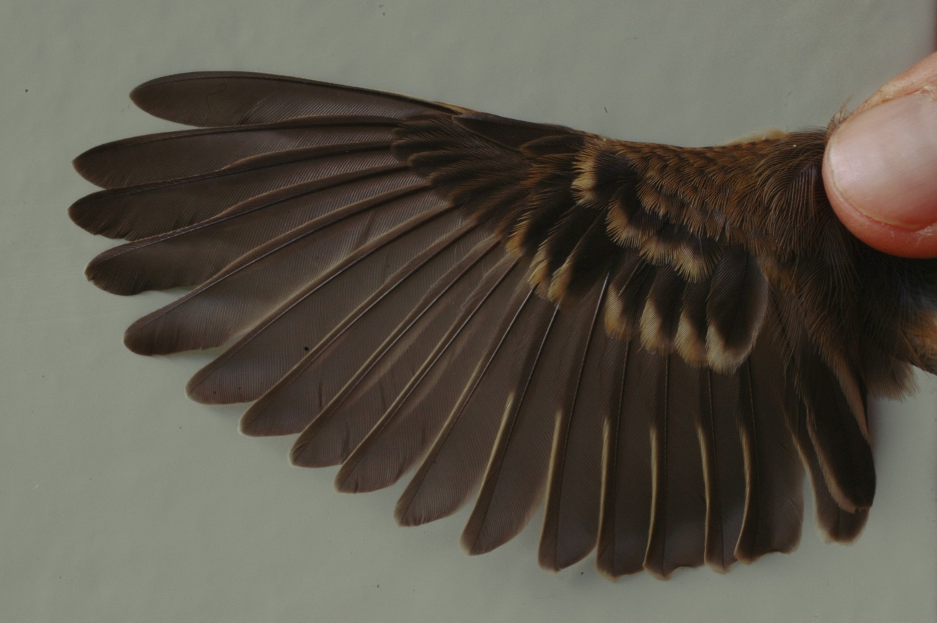
Buff-breasted Flycatcher. Retained juvenile outer GC and MC have buffier margins.
31 August 2005.
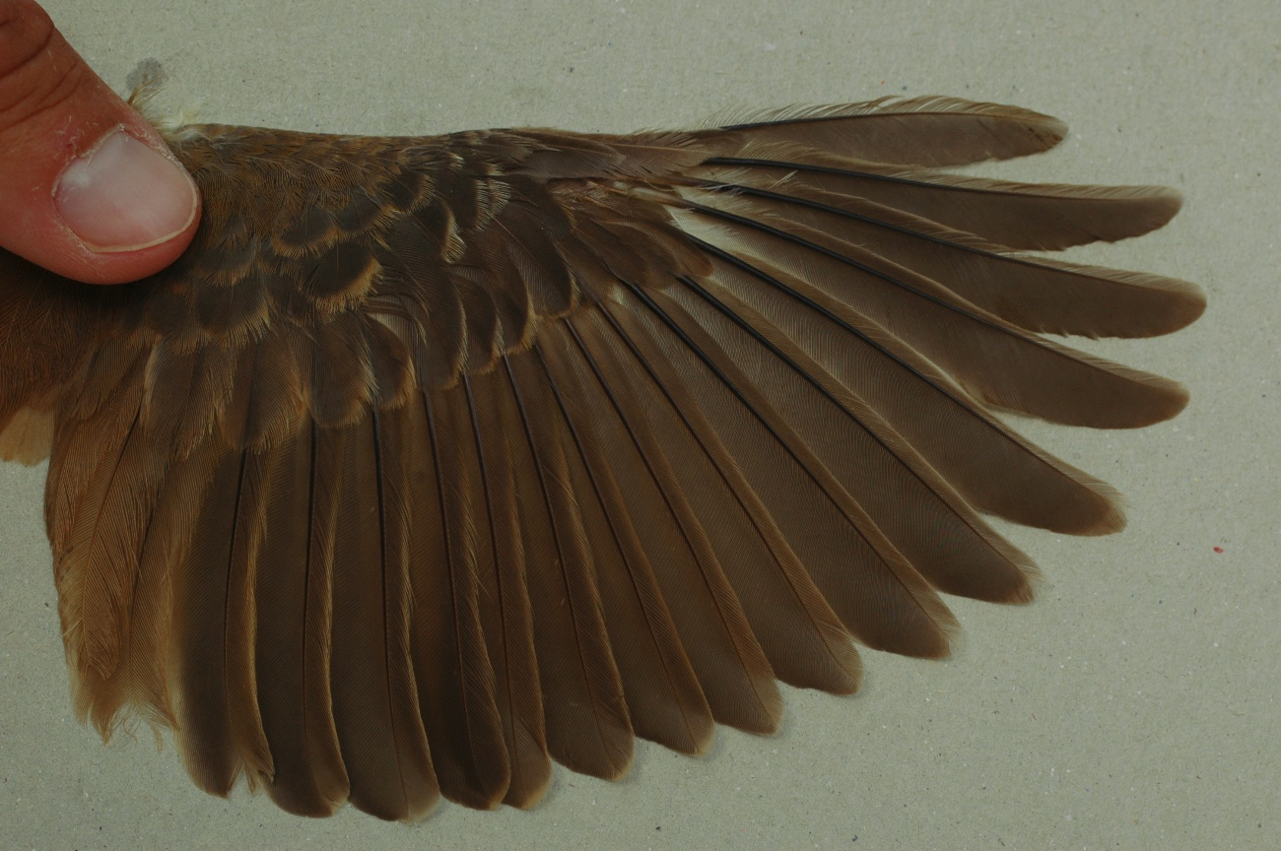
Bright-rumped Attila. Formative wing coverts and alula are paler and have narrower margins.
15 June 2005.
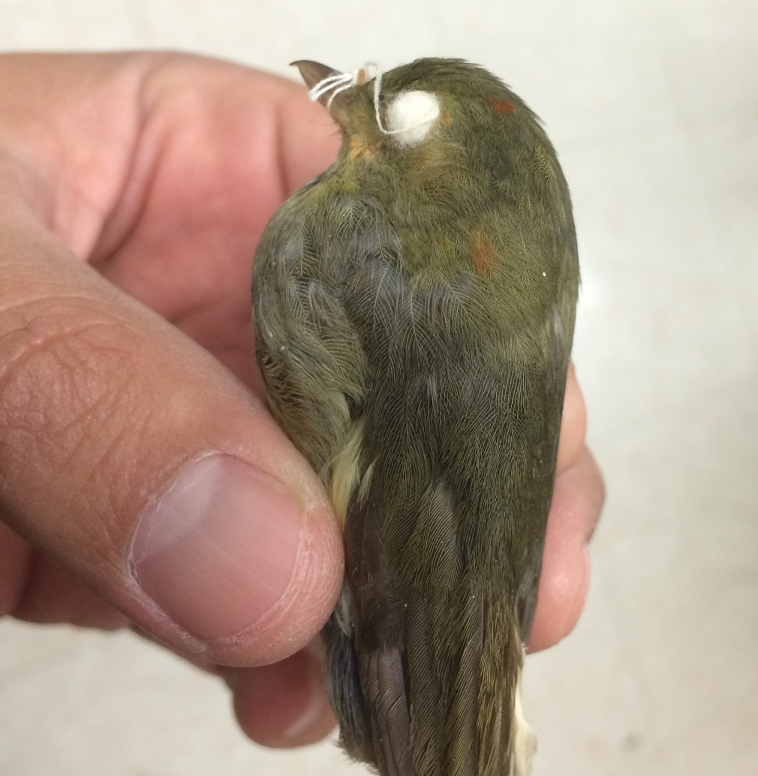
Red-capped Manakin. Formative wing coverts have brighter margins.
27 May 1995.
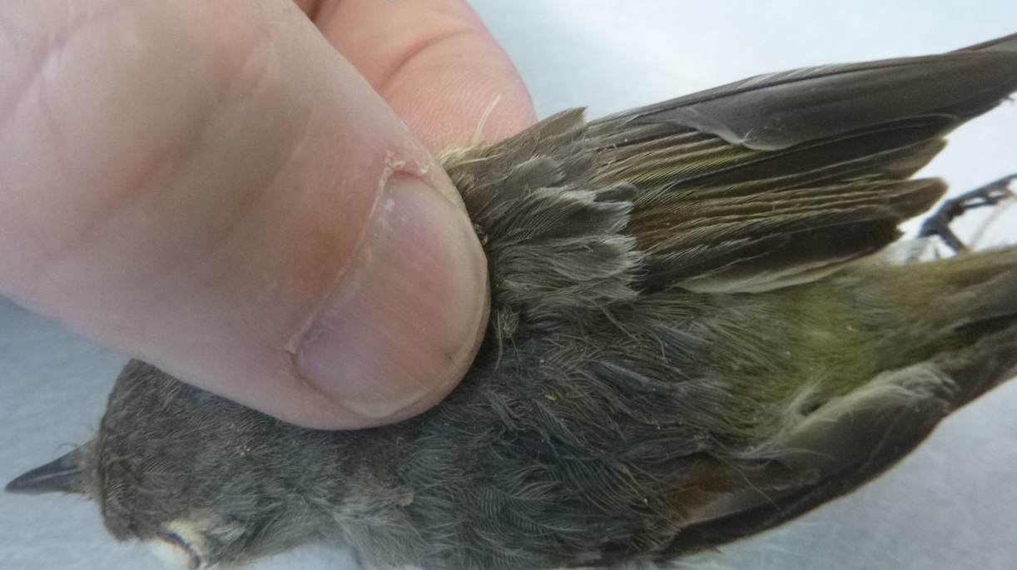
Hutton's Vireo. Retained outer GC are paler, with more abraded margins.
29 July 1948.
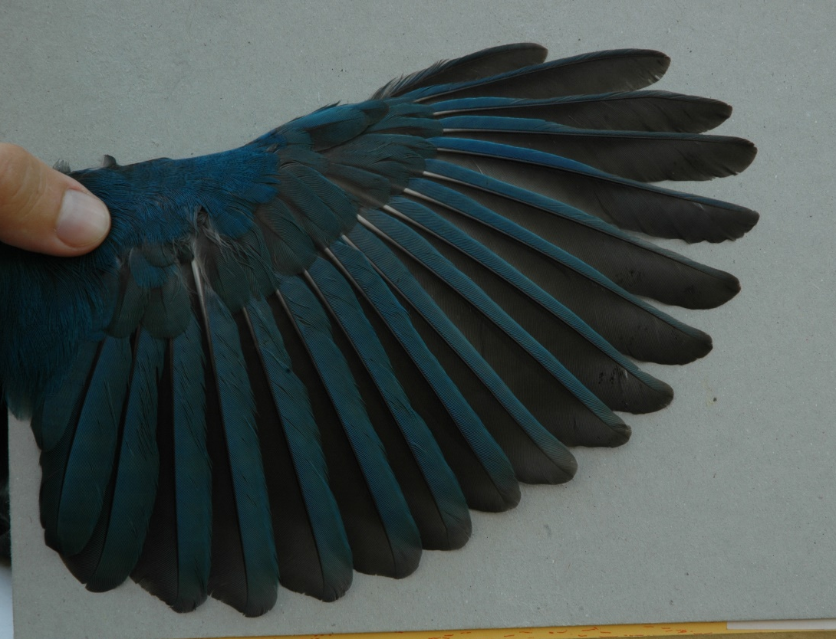
San Blas Jay. Formative LC and MC are bright blue, whereas juvenile GC are greyer.
30 December 2004.
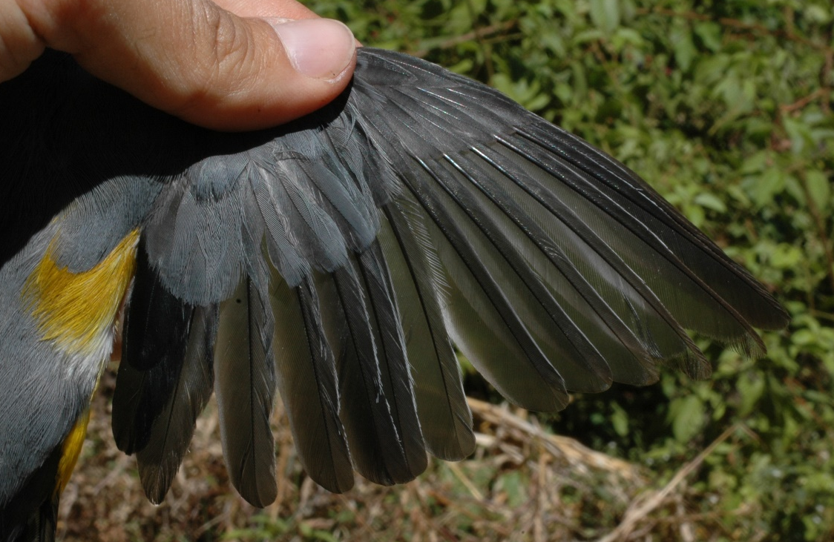
Gray Silky-Flycatcher. Formative tertials are clearly darker.
29 April 2005.
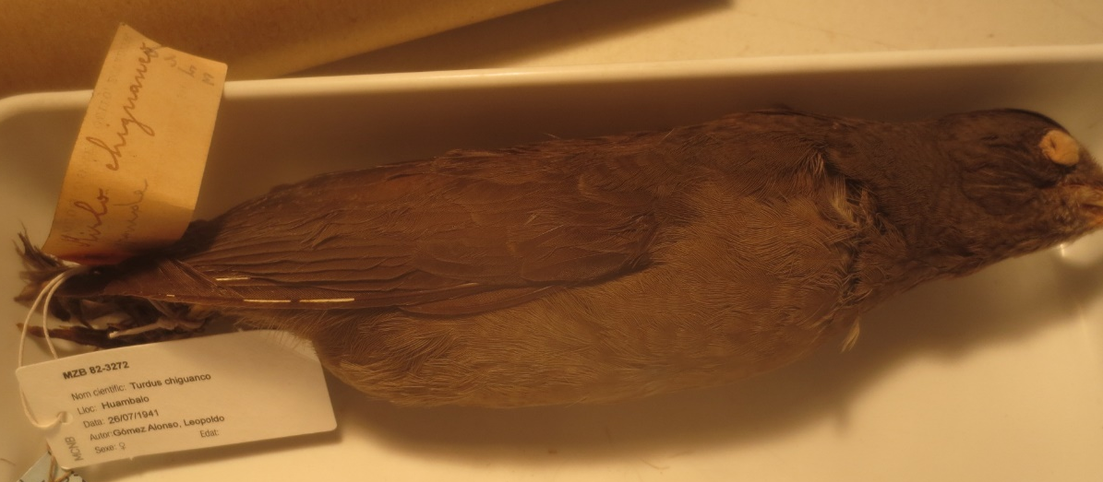
Chiguanco Thrush. Retained greater coverts have buffy tips, although these wear off at the end of the first annual cycle, like this individual 26 July 1941
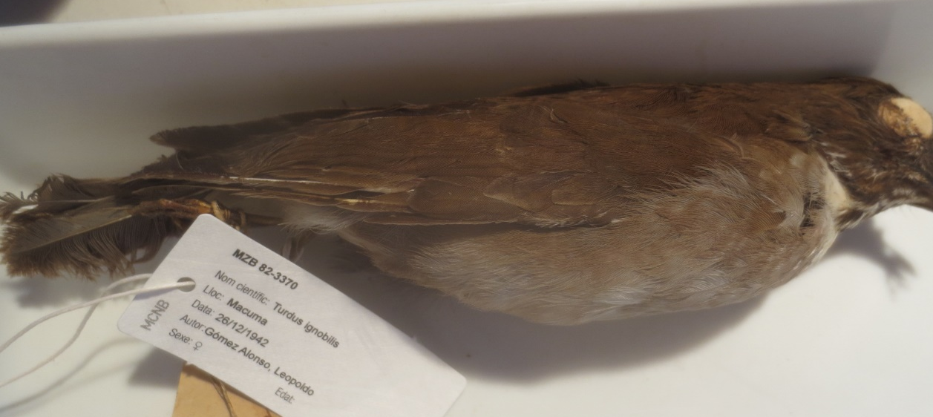
Black-billed Thrush. Retained greater coverts are paler with buffy margins. 26 December 1942.
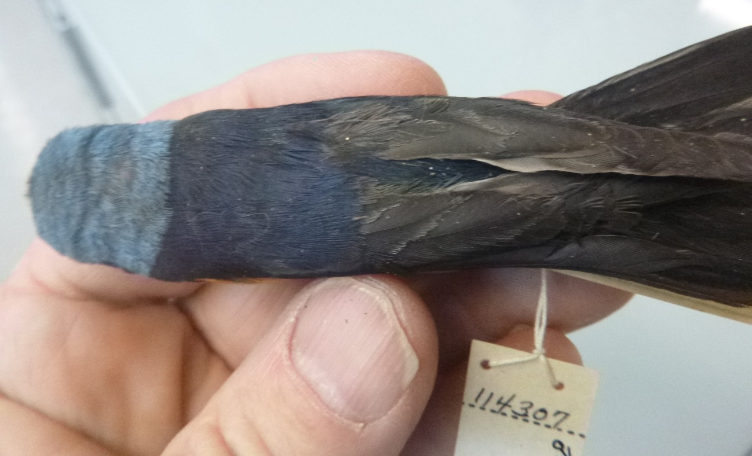
Elegant Euphonia. Blue formative GC clearly contrast with retained remiges.
9 July 1941.
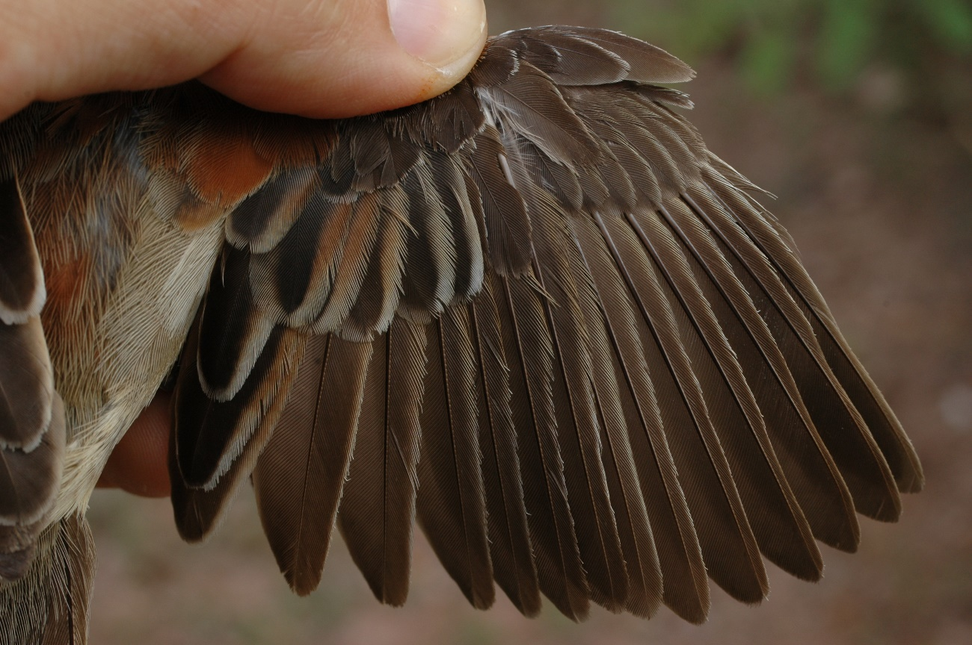
Black-chested Sparrow. Retained worn and faded wing feathers clearly contrast with fresh alternate ones. Notice inverted pattern of replacement.
15 September 2005.
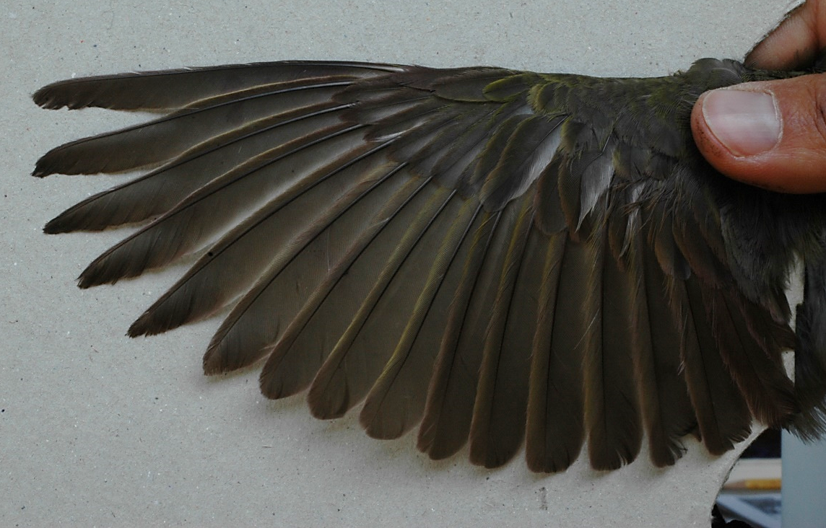
Hepatic Tanager. Retained primary coverts and alula feathers are clearly paler and more worn. 20 May 2005.
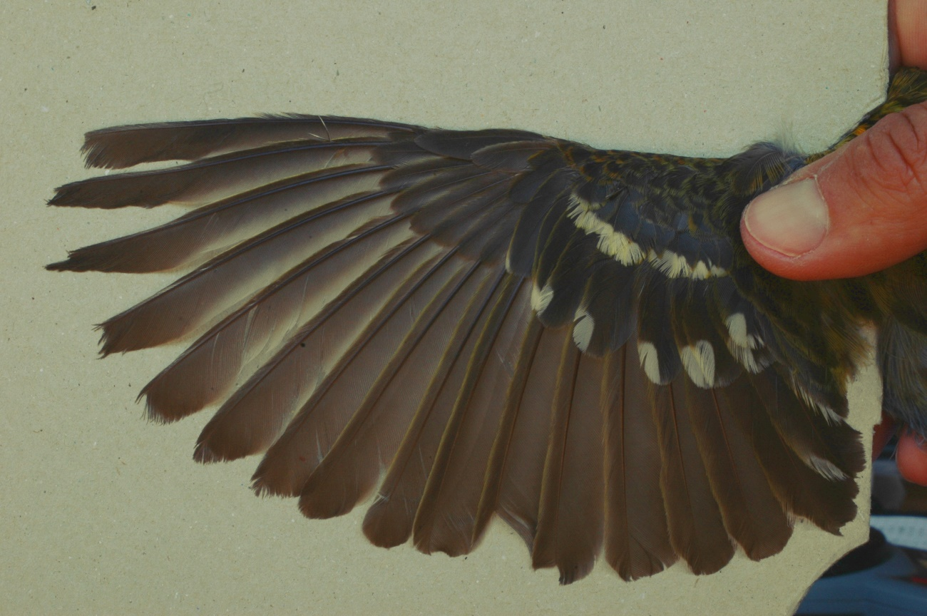
Flame-colored Tanager. Darker tertials, alula covert and greater coverts clearly contrast with adjacent feathers.
23 May 2005.
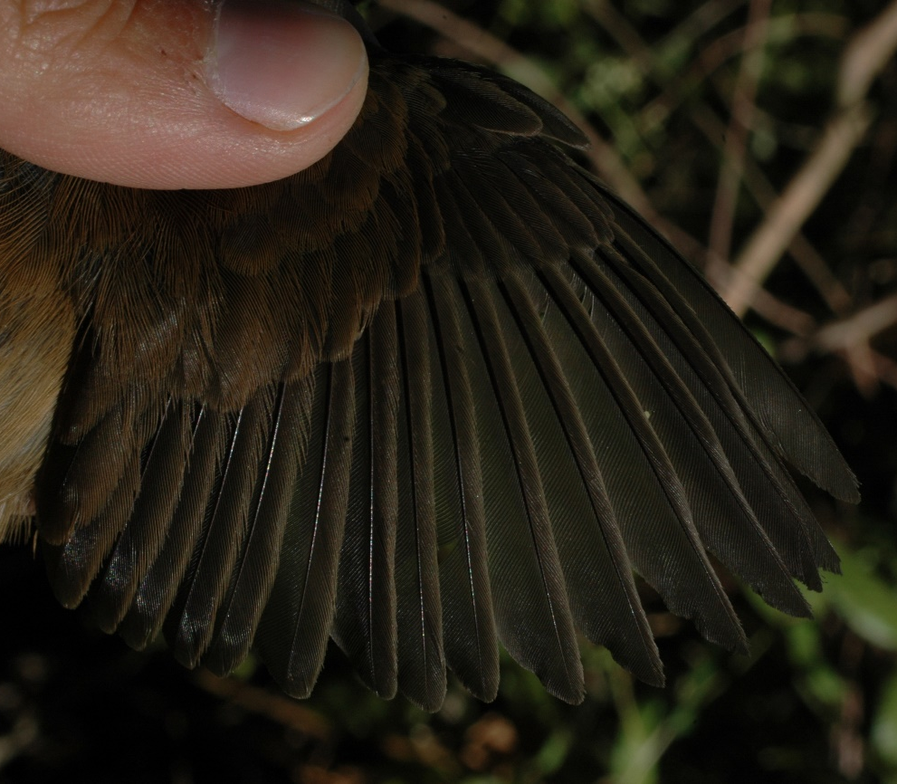
Blue Seedeater. Retained juvenile GC present a narrow buffy margin.
10 March 2005.
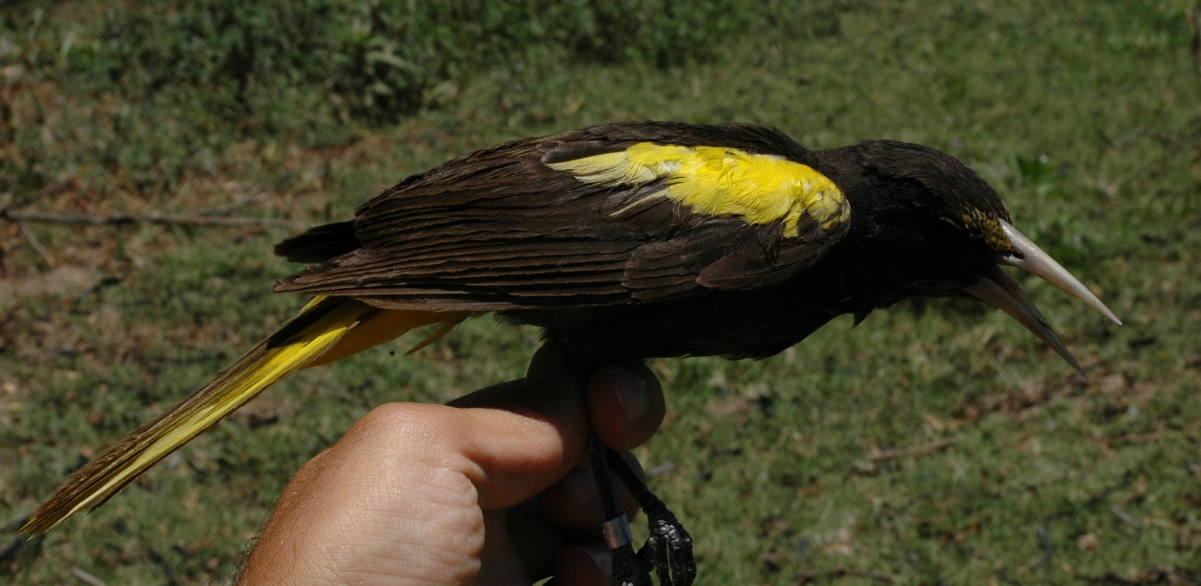
Yellow-winged Cacique. Retained juvenile GC are clearly paler. Alula and remiges are browner and contrast with the formative feathers.
4 May 2005.

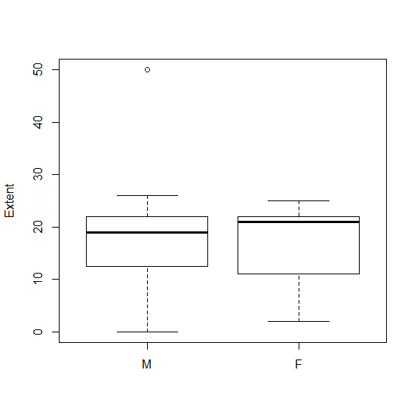 Fig S2. Sex differences in molt extent. (Welch two sample t-test: t = 0.202, df = 118.42, p = 0.840). The box lines correspond to the three quartiles, the whiskers are obtained multiplying the interquartile times 1.5 (see https://www.r-bloggers.com/about-boxplot/). n_{M}= 75, n_{F}= 52
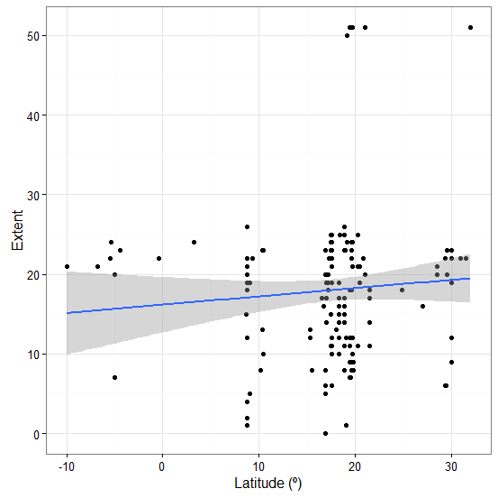
Fig S3. Linear regression of latitude on molt extent and 95% confidence intervals for our dataset. Points correspond to individual birds. Extent= 16.176 + 0.104·latitude; (F_{1,166}= 1.223, adjusted R²= 0.001, p= 0.270).

Table S1. Moult patterns considered for describing the pattern signature in our dataset (based on Guallar & Jovani in prep.). Mode of replacement is the hypothetical underlying physiological mechanism of control, which switch on or off certain areas of the wing allowing or excluding the renewal of the involved feathers.
pattern | Description (Desc)  Example (Ex) | Mode of replacement
complete | Desc: Full feather replacement.  Ex: Preformative moult of House Sparrow Passer domesticus | Conserved moult sequence: start at primary 1, replacement of primaries accompanied by respective primary coverts.
eccentric | Desc: Retention of inner primaries, secondaries and primary coverts.  Ex: Preformative moult of Passerina buntings. | Nodal remiges differ from those of complete moults; coverts may grow in before primaries, which are not accompanied by their corresponding primary coverts.
general | Desc: Partial replacement which does not include primaries nor primary coverts.  Ex: Preformative moult Great Tit Parus major. | From leading to trailing edge of wing: filling of an entire feather tract before proceeding with the next.
proximal | Desc: Partial replacement which does not include primaries nor primary coverts. Differs from the general pattern in mode of replacement.  Ex: Preformative moult Winter Wren Troglodytes troglodytes. | From leading to trailing edge of wing: prioritisation of feathers closer to the body before finishing replacement of anterior tracts.
inverted | Desc: Partial replacement basically of secondaries and greater coverts. May include primaries and primary coverts.  Ex: Prealternate moult of Spotted Flycatcher Ficedula hypoleuca | From trailing to leading edge of wing: prioritisation of basal feathers of posterior tracts over median and lesser coverts.
limited | Desc: Replacement of lesser and or median coverts, including the carpal covert.  Ex: Preformative moult of nuthatches, treecreepers and kinglets. | Prioritisation of replacement from leading to trailing edge of area and from basal to distal feathers within it.
reduced | Desc: Replacement of one to a few secondaries and or greater coverts. Strongly asymmetrical moults are considered accidental.  Ex: Spring moult of some Myiarchus flycatchers. | Activation of follicles from a small wing area near the body.

