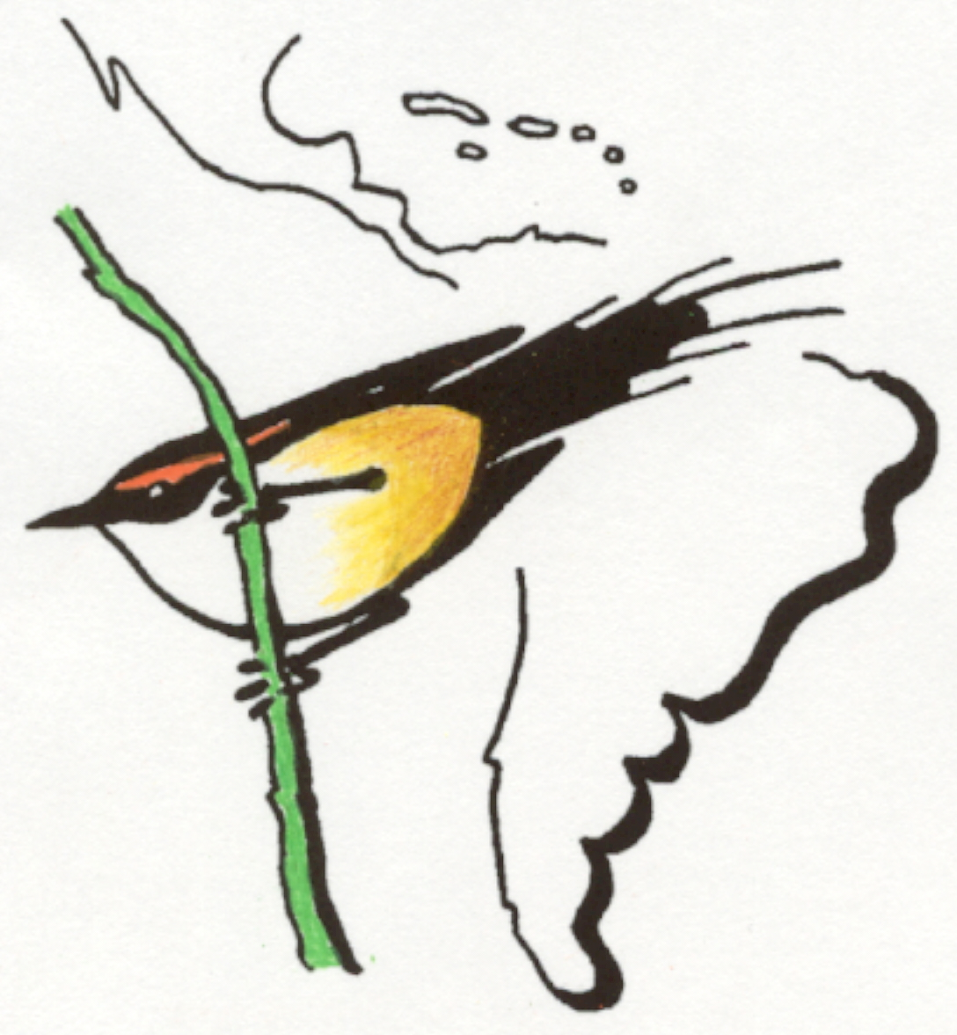
ORNITOLOGIA NEOTROPICAL

An International Journal of Neotropical Ornithology
published by the
NEOTROPICAL ORNITHOLOGICAL SOCIETY

Dr. André-A. Weller, Copy Editor
Zoologisches Forschungsmuseum A. Koenig, Adenauerallee 160,
53113 Bonn, Germany; a.weller@zfmk.de
————————————————————————————————————————————–
Bonn, 1 July 2016 MS: 61-455

Dear authors,

Your manuscript entitled
DIETA DEL CORRELIMOS DIMINUTO (CALIDRIS MINUTILLA) EN CULTIVOS DE ARROZ ORGÁNICO DE COLOMBIA

is foreseen for publication in Vol. 27 of Ornitología Neotropical and will occupy 8 printed pages (new format/12 in old format). You and the co-author(s) or your institution of attachment need to pay US$ 50,- per printed page in case of Original articles exceeding 10 printed pages (old format), or Technical notes exceeding 4 pages, to contribute to page costs. Your page costs will be US$ 50,-, which includes a discount for one page.
In addition, due to corrections necessary in text (esp. References) and graphics, i.e. reformatting of Table 1 during the final revision/layout phase, there will be extra costs of US$ 50,-. The total costs for your pages are US$ 100,-.

Please note that without contributions of authors the publication of ON cannot be maintained. Please send your payment to ensure publication of your manuscript in the above-mentioned issue of the journal. You are invited to send this payment according to the instructions on our website: http://neotropicalornithology.org/membership/
Currently, authors can pay using PayPal (with credit card), and should use the donation option and include their manuscript number within the "special instructions" box.

Please send your payment, with copy of this letter, to (with cc to me):

Molly McDermott
Treasurer, Neotropical Ornithological Society
42 E. Pacemont Rd., Columbus, OH, USA
nostreasurer@gmail.com

Thank you for considering ORNITOLOGIA NEOTROPICAL for the publication of your work.

Sincerely,
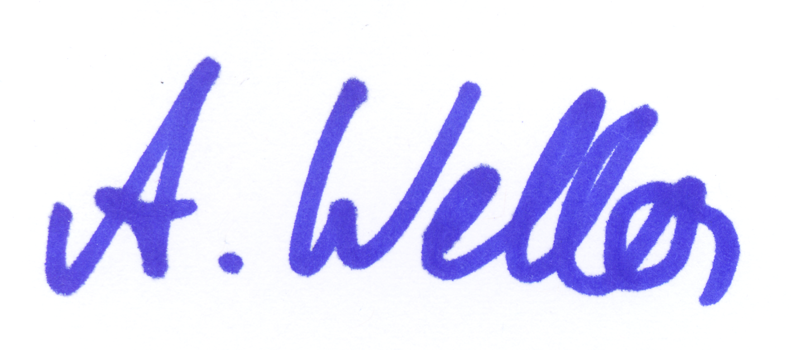
André Weller

